Speeding up PDF display

Why change the PDF display behaviour? 1
Firefox 2 2
Internet Explorer 7 5

Why change the PDF display behaviour?
Some of the primary source PDF files are huge and can take quite a while, more than a minute on some slower machines, to load. But this can all be speeded up, and it can be done quite easily if you are using Firefox 2.
The primary source documents in the Scholar’s Toolbox are provided as PDF (Portable Document Format) files. This popular file format requires a PDF Viewer program, the most popular of which is Acrobat Reader. It’s popular because it is quite capable and it is free. Most computers will have a PDF viewer already installed. If not, downloading and installing one is free and only takes a few minutes.
Web browsers can display PDF files in the current browser window or in a separate window just for the PDF Viewer. The latter generally preferable for the Scholar’s Toolbox. It is not only much faster with the large files, but it makes it much easier to load two files into Acrobat Reader side by side for comparison, which is what many people will wish to do with these files.
The reader should note that once a PDF file is opened in a new window, the browser’s “back” button won’t close that new window and the only way to “go back” is to close the new PDF Viewer window. Also, some PDF Viewers allow you to modify the file being displayed. Be aware of this since unintended modifications may not be desirable. Of course if you are working from CD or DVD files, those files are not “re-writable.” If you copy the files to your hard disk, however, you may end up inadvertently altering the files. This is particularly the case if you are using Acrobat Professional or Foxit as your PDF Viewer.
Unfortunately, I am not an expert on this issue and I have only recently discovered that the PDF viewing behaviour of some browsers, at least, can be toggled back and forth between these two options.
It is pretty simple to do it with the Firefox browser and while I’ve read assurances that it can be done with Internet Explorer 7, and I even have instructions on how to do it (see below), I have not been able to get those instructions to work successfully on my equipment. I will include them with that caveat. You may be able to get it to work on your computer.
Everything here is assuming the use of Adobe Acrobat Reader or Adobe Acrobat Professional, either version 7 or version 8, as the PDF viewer. There are other PDF viewers in the world, notably Foxit. While Foxit is a fine package, I have not been able to get it to work on the two largest PDF files in this compilation. It just hangs, not on initial loading, but as soon as you try to navigate within the large files. It therefore cannot be considered compatible with this compilation even though it works fine on most of the files.
Other PDF viewing software may work, but it has not been tested.

Firefox 2
This option not only loads large PDF files using Acrobat much more quickly – almost instantly – it allows for much easier side by side comparison of any two (or more) files.
Now on my computer running Firefox 2 under Windows XP using the latest Mircrosoft updates as of June 2, 2008, there is a simple option to modify the way Firefox handles PDF files.
The default mode is for Firefox to load the PDF page within the browser. This is fine for any smaller single file. The small ones load reasonably quickly. However if you wish to compare two files, for instance the facsimile with the e-text, you’ll likely want to get both files into the PDF reader and then “tile” them horizontally or vertically to get a side-by side display. This is easy by loading the PDF files directly into Acrobat Reader from Windows Explorer but that requires navigation through the directories and identification of file names. You can’t do that directly from the menu in the default Firefox configuration.
However, after fiddling with Firefox to get Foxit to work as a “plug-in” I found, after uninstalling Foxit that from the Scholar’s Toolbox menu, Acrobat was loading independently, outside the browser in a new window rather than in the browser window. When clicking from the menu two PDF files can be loaded in that new PDF viewer window, allowing me to “tile” the two side by side. Generally this is much preferred behaviour for the user of the Toolbox!!
Upon further investigation I found I can “toggle” Firefox to do it either way.

The same desirable change in behaviour was noted in Internet Explorer 7 after installing and then uninstalling Foxit but I have been unable to discover how to intentionally cause or reverse that change of behaviour in IE7 or IE6 otherwise. If anybody knows, please let me know!! I did achieve this effect with IE7 by installing Foxit, making it the default PDF program, and then uninstalling it. That’s simple to describe but hardly an elegant, quick or easy means of doing it! And so far, it seems to reverse it, I need to uninstall and then reinstall Acrobat and possibly even IE 7.
But in Firefox it is a snap. Here’s how to do it:
From the Firefox TOOLS menu click on Options. A dialog box appears (see screen shot below). Click the Content tab and then the Manage button. Scroll through the dialog box which then appears to PDF and then click on “Change Action.” What you should see is pictured in this screen shot (below).
From top to bottom, left to right, this is the order of the dialog boxes that come up for me. The last is the one on the lower right. Here I have the topmost of the four circles designated “Open them with the default application” although as installed, Firefox has the “Use this Plugin” option selected. When that lower option is selected, Acrobat loads the file within the browser window while when the topmost option is selected, Firefox loads Acrobat in a new window which allows multiple files to be loaded and tiled or cascaded in that new window. The latter behaviour is most useful for users of the Scholar’s Toolbox who wish to view documents side by side. You can then load those documents easily into the Acrobat window by clicking on the appropriate spots on the menu.

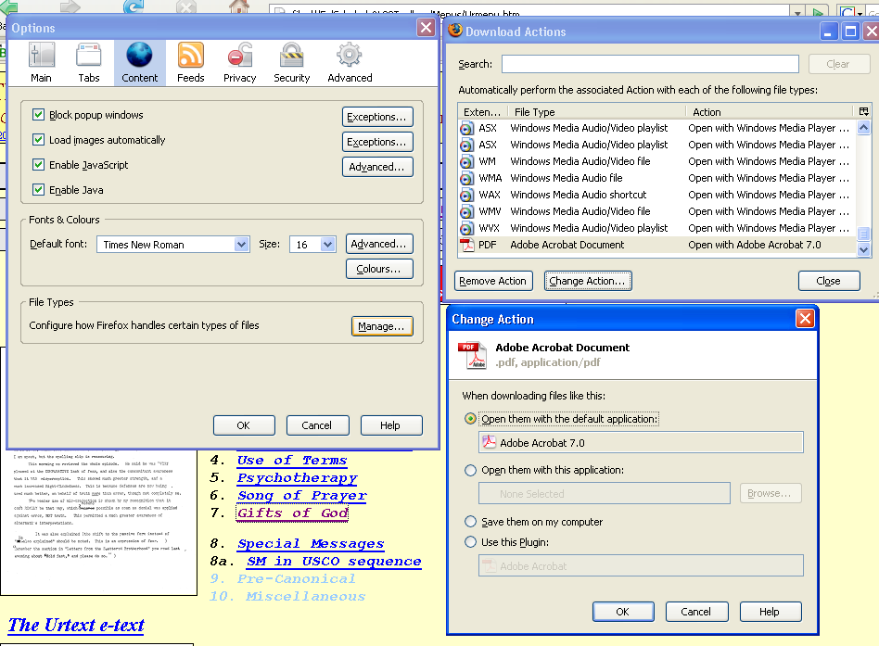

Firefox dialog boxes showing how to change PDF display behaviour

Internet Explorer 7
Below are instructions found on the net at:
http://kb.adobe.com/selfservice/viewContent.do?externalId=333544#IE7
I have not been able to get these instructions to work on my setup BUT I did manage to get IE7 to open PDF files in a new window by installing Foxit, setting it as the default, and then uninstalling it. I don’t know how to shift this back but I expect uninstalling and reinstalling would do it.
Configure Internet Explorer or AOL to display PDF files for Acrobat and Adobe Reader (8.0 and 3D 8 on Windows)

What's covered
Configuring the browser to open PDF files within the browser window
Configuring the browser to open PDF files in an Acrobat window
Downloading a PDF file to your hard drive
Internet Explorer 7 and Acrobat
Interoperability of Acrobat and Adobe Reader 7 and Acrobat Adobe Reader 8
Interoperability of Acrobat and Adobe Reader 6 and Acrobat Adobe Reader 8
You can configure your web browser to open PDF files either in the browser window or in a separate Adobe Acrobat window. To configure the browser, you must have Adobe Acrobat or Adobe Reader installed. Acrobat and Adobe Reader include ActiveX plug-in files that allow you to use Microsoft Internet Explorer or AOL to view PDF files on Windows.

Configuring the browser to open PDF files within the browser window
When you install Acrobat or Adobe Reader on a system that includes a browser, you automatically configure the browser to open PDF files within the browser window. Acrobat and Adobe Reader install ActiveX plug-in files that allow you to use Internet Explorer or AOL to open PDF files. If either application is installed, but PDF files don't open in the browser window, then work through the following steps to configure the browser:

1. Make sure that the system meets the requirements for the Acrobat product you use.
Acrobat may not run correctly if the system doesn't meet the following requirements:
Intel Pentium III processor or equivalent
Microsoft Windows 2000 with Service Pack 4 or Windows XP Professional, Home Edition, or Tablet PC Edition with Service Pack 2
Microsoft Internet Explorer 6.0
256MB of RAM (512MB recommended)
860MB of available hard-disk space; cache for optional installation files (recommended) requires an additional 460MB of available hard-disk space.
1,024x768 screen resolution

2. Make sure that the ActiveX folder contains files required for web browsing.
To open PDF files in a browser window, the ActiveX folder must contain the following files: AcroPDF.dll, AcroIEHelper.dll, and pdfshell.dll.
The ActiveX controls should be located in: Program Files\Common Files\Adobe\Acrobat\ActiveX
If any of these files are missing, then repair Acrobat or Adobe Reader by choosing Help > Repair Acrobat Installation, or reinstalling the application.

3. Use a supported version of the browser.
Make sure that you use a version of your web browser that Acrobat and Adobe Reader support, such as Internet Explorer 6. Supported browsers for Adobe Acrobat 8, Adobe Reader 8 are Internet Explorer 6.0, 6.0 SP1, Internet Explorer 7.0, Firefox 1.5 or later, Mozilla 1.7, and AOL 9.

4. Restart Windows after you install Acrobat or Adobe Reader to update the Windows registry.
To ensure that the Windows registry provides the information your web browser needs to view PDF files, restart Windows. If the Windows registry doesn't update after you install Acrobat, then the web browser may not find the references it needs to access PDF files on the web.

5. Remove older versions of Acrobat or Adobe Reader.
If you have an older version of Acrobat or Adobe Reader installed on the system, then use the Add Or Remove Programs utility in Windows to remove it.

6. Repair Acrobat.
If you use Acrobat, then repair or replace corrupt or missing files by using the Repair Acrobat Installation feature or the Add Or Remove Programs dialog box.
To repair Acrobat:
Choose Start > Control Panel.
Double-click Add Or Remove Programs.
Select Acrobat and click Change.
Follow the on-screen instructions to repair Acrobat.
7. Reinstall Acrobat or Adobe Reader.
To ensure that the correct plug-in information is added to the Windows registry, reinstall Acrobat or Adobe Reader.

Configuring the browser to open PDF files in an Acrobat window
If you want the browser to open PDF files in a separate Acrobat window, then configure the browser to use Acrobat or Adobe Reader as a helper application. Then, when you select a PDF file in Internet Explorer or AOL, the browser opens the PDF file in an Acrobat window instead of the browser window.
To configure the browser to use Acrobat or Adobe Reader to open PDF files:
Close your web browser.
Start Acrobat or Adobe Reader.
Choose Edit > Preferences.
Select Internet in the list on the left.
Deselect Display PDF in Browser, and click OK.
Restart Internet Explorer or AOL.
Note:The next time you select a link to a PDF file, the browser may prompt you to open or save the file. If you choose to open the file, then the browser opens the file in the helper application that you specified. If you choose to save the file, then the browser downloads the file to the hard disk.
For more information about the general preferences in Acrobat or Acrobat Reader, refer to the Acrobat Help.

Downloading a PDF file to your hard drive
You can download a PDF file to the hard drive from a web page's link. Downloading PDF files doesn't require the ActiveX plug-in file to be installed. (If you want to open and view the PDF file after downloading it, you must have Adobe Acrobat or Adobe Reader installed.)
To download a PDF file from a link:
Right-click the link to a PDF file, and then choose Save Target As from the pop-up menu.
In the Save As dialog box, select a location on your hard drive, and then click Save.

Internet Explorer 7 and Acrobat
Internet Explorer is supported for use with Acrobat and Adobe Reader version 7.0.8 and 8. For versions of Acrobat earlier than 7.08, most functionality will work, but there may be issues with forms workflows. If you run into any sort of issue, then you should upgrade to at least Acrobat or Adobe Reader 7.0.8.
Internet Explorer 7 makes it more visible to the user which add ons are enabled and disabled. This is done from the tools menu by selecting Manage Add Ons.
After installing Adobe Acrobat/Adobe Reader, the following add-ons can be listed: Adobe PDF, Adobe PDF Context Menu Helper, Adobe PDF Conversion Toolbar Helper, Adobe PDF Reader, Adobe PDF Reader Link Helper, Adobe PDF Reader Link Helper.
The first three add ons are associated with the PDF tool bar that is installed by the full Acrobat product. The second three add ons that can be seen are installed with both the Reader and the full Acrobat product. By default, all of these add ons are enabled.
Internet Explorer 7 allows you disable individual add-ons, and it has a ?Reset? button (available from the Tools, Internet Options menu, under the Advanced Tab) that disables all Add ons. By disabling the Adobe add-ons, some PDF-related functionality may no longer work.
When Adobe Acrobat or Adobe Reader launches and it notices that add ons are disabled, it will return the following error message. "One or more Adobe PDF extensions are disabled. This may impact how PDFs are displayed in Internet Explorer. Please go to Manage Add-ons in Internet Explorer and enable add-ons from Adobe. You will need to restart Internet Explorer after performing this action."

Interoperability of Acrobat and Adobe Reader 7 and Acrobat Adobe Reader 8
When you install Acrobat 8 or Adobe Reader 8 and there is already an installation of Acrobat 7 or Adobe Reader 7 on the computer, the version 8 browser components will be installed, no matter what version of Acrobat or Adobe Reader is chosen to own the PDF mime type during installation. This is because the version 8 browser components work with both version 7 and version 8.
If, however, after installation of Acrobat 8 or Adobe Reader 8, you manually repair the installation of Adobe Acrobat 7 or Adobe Reader 7, the version 7 browser components for will be reinstalled. Trying to use version 8 to view a PDF file in the browser after this will result in an error message. In such a case, you must manually repair the version 8 installation by going to Help > Repair Acrobat Installation from Acrobat or Adobe Reader 8.

Interoperability of Acrobat and Adobe Reader 6 and Acrobat Adobe Reader 8
The Adobe Acrobat 8 and Adobe Reader 8 installers allow the installation of version 8 to coexist with version 6. They do not, however, give a choice of mime type ownership. Version 8 of the PDF viewers will own the PDF mime type.
If you use Acrobat 6 or Adobe Reader 6 standalone to view a PDF file in the browser after you install Acrobat 8 or Adobe Reader 8, an error message will appear stating that the version of Acrobat that is running is not supported and to exit it and try again.
If you repair Acrobat 6 or Adobe Reader 6 after the installation of Acrobat 8 or Adobe Reader 7, then the Acrobat6 or Adobe Reader 6 browser components will be reinstalled. If you try to to use Acrobat 8 or Adobe Reader 8 to view a PDF file in the browser after, then you will see an error message. In such a case, manually repair the version 8 installation by going to Help > Repair Acrobat Installation from Acrobat or Adobe Reader 8.

TechNote Details
Last Update: | 06-21-2007
ID: | 333544
OS: | Windows
Permanent Link: | http://www.adobe.com/cfusion/knowledgebase/index.cfm?id=333544
Products Affected: | Acrobat Professional

